**Reg. No. 21BCE1297 Name: Vidhi Shah Date of Submission: 02/03/22**

**Experiment 1: Study of Electronic Components and Electronic Measurement Devices**

**Basic Points:**

**Electronics:** Mechanics of electron

There are 4 main type of analyses:

* DC analysis
* DC Operating Point analysis
* Transient analysis
* AC analysis

**Ohm’s Law:** Current is directly proportional to the voltage and constant of proportionality is 1/R under constant temperature and pressure conditions.

Limitation of KCL:

* Only applied when electric charge in the circuit is constant
* Not applicable for high frequency AC circuits
* Not applicable for non-conservative circuits

Limitation of KVL:

* Only applied when magnetic fields do not change
* Not applicable for high frequency AC circuits
* Not applicable for non-conservative circuits

**Passive Devices:** (Require no additional power source)

**1) Resistor:**

* Regulate or set the flow of electrons (current) through them.
* Electrical energy is lost in the form of heat in resistor.
* Resistors can be connected together in series or parallel combinations.
* 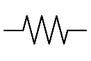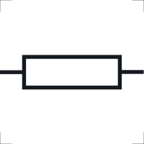Resistors are used as voltage droppers, voltage dividers and current limiters in the circuit.

, Resistance(R) is measured in ohms(Ω).

Symbol in circuit:

Types of resistors:

* Carbon Composition Resistor
* Film or Cermet Resistor
* Wire – wound Resistor
* Semiconductor Resistor

Colour coding:

* 4 bands
* 5 bands
* 6 bands

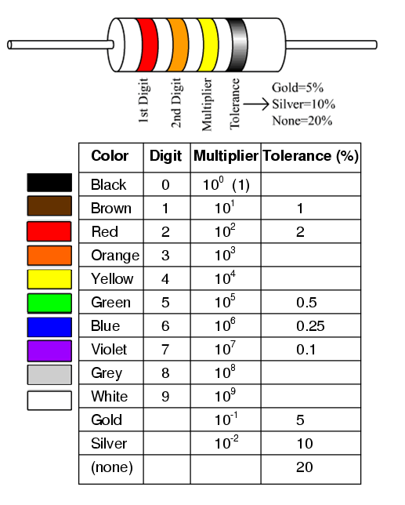

**2) Capacitor:**

* Stores energy in the form of an electrical charge producing a potential difference across its plates.
* It consists of 2 or more parallel plates which are electrically separated by air or a good insulating material. This insulating layer is called the Dielectric.
* , Capacitance(C) is measured in Farads(F).

File:Capacitor Symbol alternative.svg - Wikimedia CommonsSymbol in circuit:

Type of capacitors:

* Electrolyte Capacitors
* Ceramic Capacitors

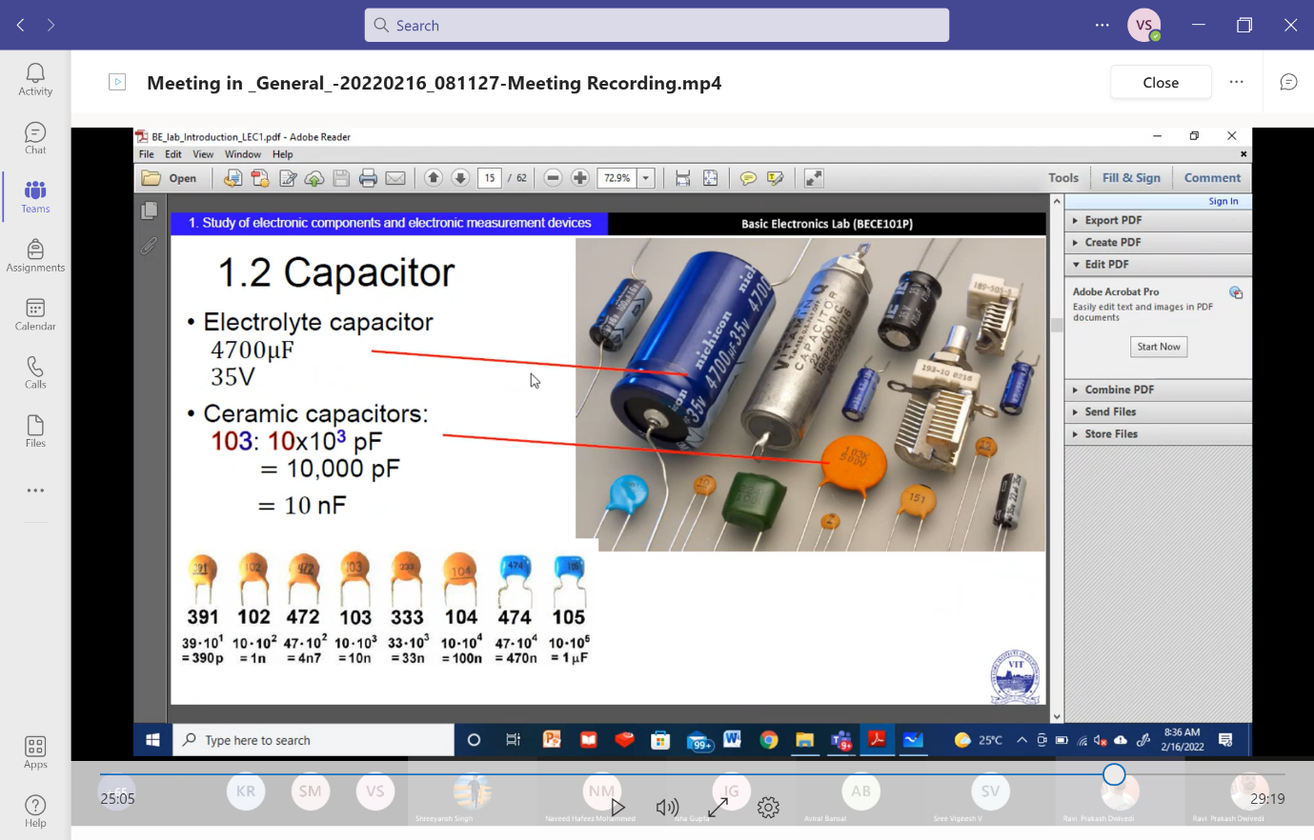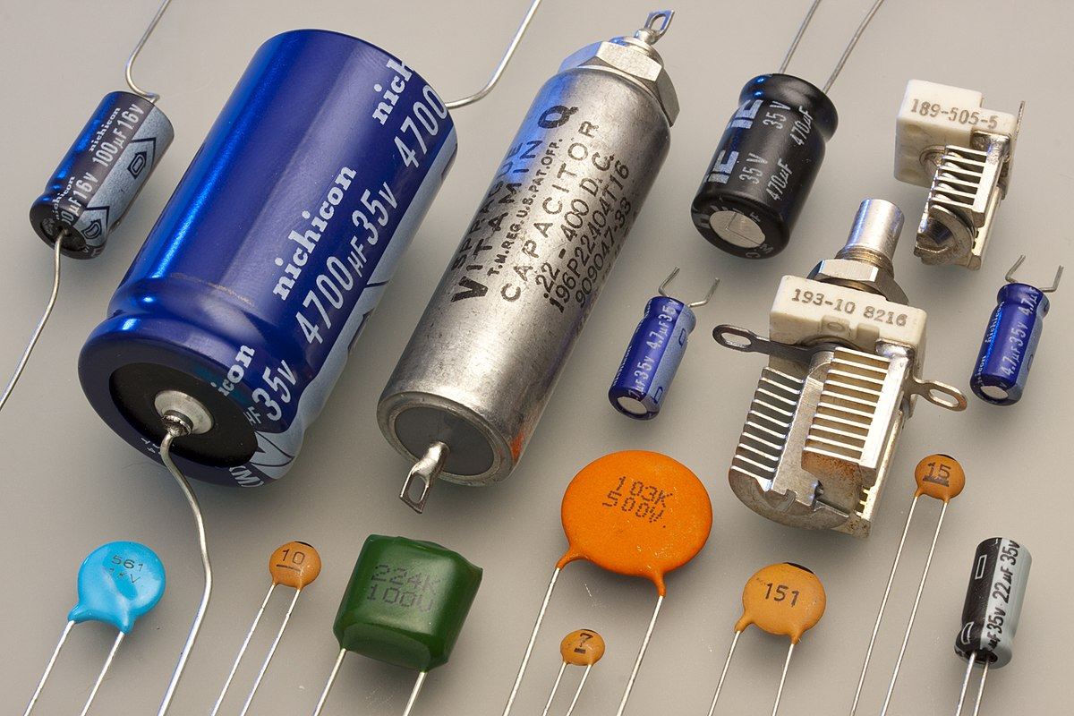

Ceramic Capacitor

Electrolyte Capacitor

**3) Inductor:**

* Inductor stores energy in a magnetic field when electric current flows through it.
* It consists of an insulated wire wound into a coil.
* 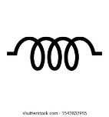Inductance is ratio of the voltage to the rate of change of current.
* , Inductance (L) is measured in Henry(H) or weber/ampere\

Symbol in circuit:

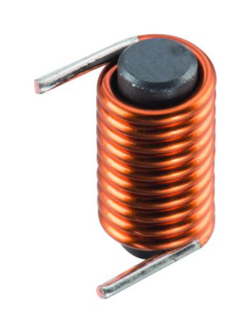

**Active Devices:**

**1) Diode:**

* Diode allows the flow of current in only one direction.
* Most common type is the *p-n* junction diode. It has two poles: P - black (+ve) and N - white (-ve)

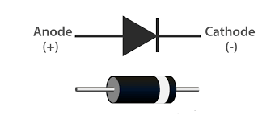Symbol in circuit:

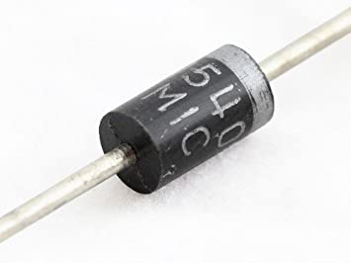

**Zener Diode**: (Breakdown diode)

* It is a semiconductor device that is designed to operate in the reverse direction.
* Zener Effect: When the voltage across the terminals of a Zener diode is reversed and the potential reaches the Zener Voltage, the junction breaks down and the current flows in the reverse direction.
* There are two types of breakdowns for a Zener Diode:
  + Avalanche Breakdown
  + Zener Breakdown

**2) Transistor:**

* It is a semiconductor device.
* Can be used as an amplifier, switch or an oscillator
* It is 3 terminals 2 port system

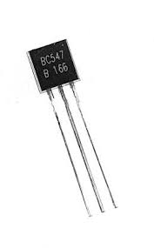

**Breadboard:**

* Breadboard used to connect electrical components.
* They are generally used for testing new circuits.
* The Horizontal holes at the top and bottom are internally horizontally shorted. The holes in the middle are shorted vertically internally.

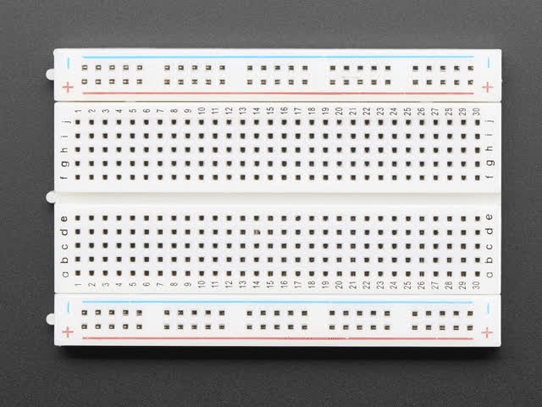

**Decade Boxes:**

They utilise a series of internal resistors, capacitors, or inductors to replicate specific electrical values in an application.

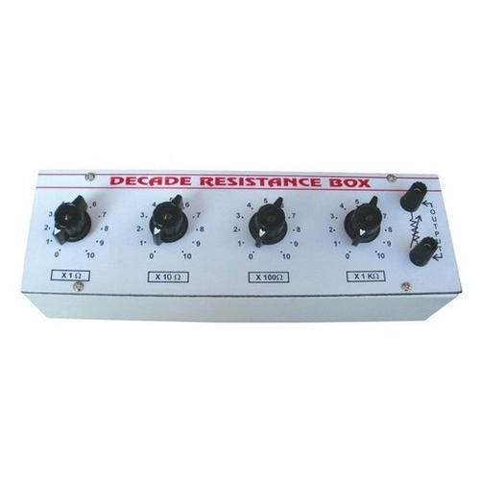**Decade Resistance Box**

**Decade Capacitance Box (µF)**

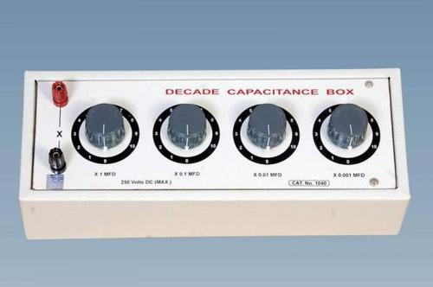

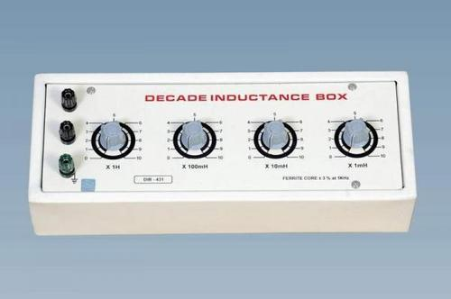**Decade Inductance Box (mH)**

**Multimeter:**

A multimeter is a [measuring instrument](https://en.wikipedia.org/wiki/Measuring_instrument) that can measure multiple electrical properties like Voltage, Resistance, Diode (sound), Capacitance, Frequency, Temp, Gain (hFE), Current (µA, mA, A)

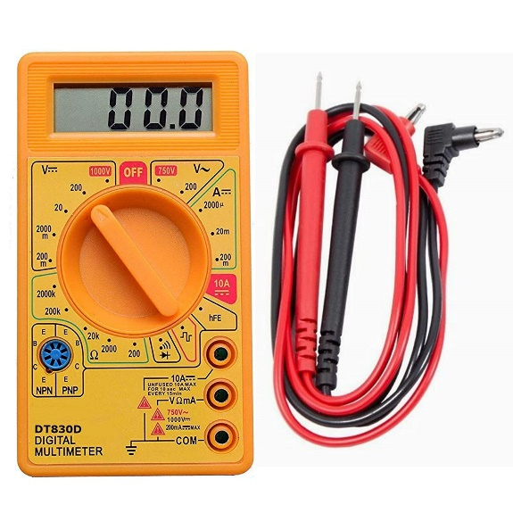

**Cathode Ray Oscilloscope (CRO):**

* It **is an electronic test instrument**
* It is used to obtain waveforms when the different input signals are given.
* By seeing the waveform, we can analyse some properties like amplitude, frequency, rise time, distortion, time interval.
* On adding capacitor to it will show ellipse graph. it is connected to function generator.

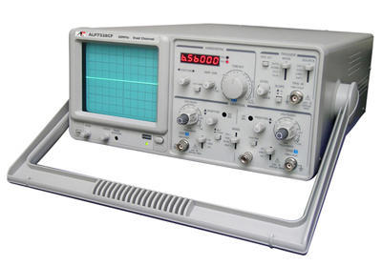

**Power supply:**

* 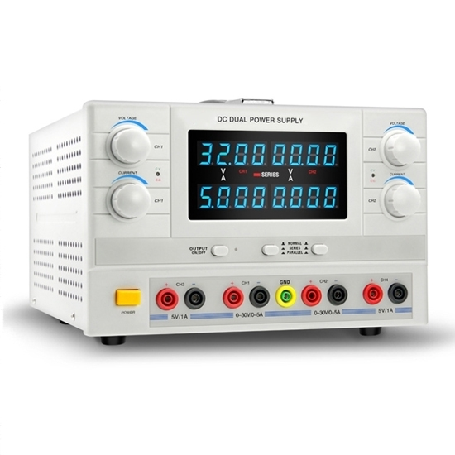It supplies electric power to an electrical load. The main purpose of a power supply is to convert electric current from a source to voltage, current, and frequency needed to power the load.

**LTSpice:**

